Lab 3: Smart Resource Allocation and Scheduling System using Greedy Algorithms
Complete Lab Report
Field | Details
Name | [sohail khan]
Roll No. | [2401201080]
Specialisation | [BCA AI DS]
Section | [B]
Lab Name | Lab 3

1. Aim
To design and implement a Smart Resource Allocation and Scheduling System using greedy algorithms, and to analyse its performance in terms of time, memory and complexity.

2. Questions Attempted

Problem 1: Activity Selection
Given activities with start and finish times, select the maximum number of non-overlapping activities. Greedy rule: sort by finish time and always pick the next activity that starts after the last chosen one finishes. Output: 4 activities (Lecture, Workshop, Viva, Demo).

Problem 2: Fractional Knapsack
Given resources with value and weight and a capacity of 50, maximise total value, allowing fractions of items. Greedy rule: take items in decreasing value/weight ratio. Output: total value 260 (CPU, SSD, RAM fully and 1/6 of GPU).

Problem 3: Job Sequencing with Deadlines
Schedule unit-time jobs with deadlines and profits to maximise profit. Greedy rule: consider jobs by decreasing profit and place each in the latest free slot at or before its deadline (union-find). Output: jobs J3, J1, J5 with profit 142.

Problem 4: Interval Partitioning (Resource Allocation)
Assign all tasks to the minimum number of resources so none overlap on one resource. Greedy rule: sort by start time and reuse the resource that frees earliest (min-heap), else open a new one. Output: 6 resources.

Problem 5: Huffman Coding
Build an optimal prefix code from character frequencies. Greedy rule: repeatedly merge the two lowest-frequency nodes. Output: 157 bits vs 320 bits for the test string, with lossless decoding verified.
Lab questions: (1) execution time, memory usage and complexity comparison table for all implemented greedy algorithms; (2) visualizations and performance graphs (resource allocation charts, activity timelines, Huffman trees, performance graphs).

3. Source Code
File: greedy_lab3.py (Python 3). Charts were generated with matplotlib.
"""
Lab 3: Smart Resource Allocation and Scheduling System using Greedy Algorithms
Algorithms: Activity Selection, Fractional Knapsack, Job Sequencing with Deadlines,
Interval Partitioning (Resource/Room Allocation), Huffman Coding
"""
import heapq
import random
import time
import tracemalloc
from collections import Counter

# ---------------------------------------------------------------- 1. Activity Selection
def activity_selection(activities):
"""activities: list of (start, finish, name). Returns max set of non-overlapping activities."""
activities = sorted(activities, key=lambda a: a[1]) # sort by finish time
selected, last_finish = [], float("-inf")
for s, f, name in activities:
if s >= last_finish:
selected.append((s, f, name))
last_finish = f
return selected

# ---------------------------------------------------------------- 2. Fractional Knapsack
def fractional_knapsack(items, capacity):
"""items: list of (name, value, weight). Returns (total_value, [(name, fraction)])."""
items = sorted(items, key=lambda x: x[1] / x[2], reverse=True) # value/weight ratio
total, taken = 0.0, []
for name, value, weight in items:
if capacity <= 0:
break
if weight <= capacity:
taken.append((name, 1.0))
total += value
capacity -= weight
else:
frac = capacity / weight
taken.append((name, frac))
total += value * frac
capacity = 0
return total, taken

# ---------------------------------------------------------------- 3. Job Sequencing with Deadlines
def job_sequencing(jobs):
"""jobs: list of (name, deadline, profit). Returns (schedule list by slot, total_profit)."""
jobs = sorted(jobs, key=lambda j: j[2], reverse=True) # highest profit first
max_d = max(j[1] for j in jobs)
# Union-Find "latest free slot" gives O(n log n) overall
parent = list(range(max_d + 1))

def find(x):
while parent[x] != x:
parent[x] = parent[parent[x]]
x = parent[x]
return x

slots = [None] * (max_d + 1)
profit = 0
for name, deadline, p in jobs:
slot = find(min(deadline, max_d))
if slot > 0:
slots[slot] = (name, deadline, p)
profit += p
parent[slot] = slot - 1
return [s for s in slots[1:]], profit

# ---------------------------------------------------------------- 4. Interval Partitioning
def interval_partitioning(tasks):
"""tasks: list of (start, finish, name). Assigns each task to the fewest resources (rooms/machines)."""
tasks = sorted(tasks, key=lambda t: t[0]) # sort by start time
heap = [] # (finish_time, resource_id)
assignment, n_res = {}, 0
for s, f, name in tasks:
if heap and heap[0][0] <= s:
_, rid = heapq.heappop(heap) # reuse free resource
else:
n_res += 1
rid = n_res # open a new resource
assignment[name] = (rid, s, f)
heapq.heappush(heap, (f, rid))
return n_res, assignment

# ---------------------------------------------------------------- 5. Huffman Coding
class HNode:
def __init__(self, ch, freq, left=None, right=None):
self.ch, self.freq, self.left, self.right = ch, freq, left, right

def __lt__(self, other):
return self.freq < other.freq

def build_huffman_tree(text):
freq = Counter(text)
heap = [HNode(c, f) for c, f in freq.items()]
heapq.heapify(heap)
if len(heap) == 1:
only = heapq.heappop(heap)
return HNode(None, only.freq, only, None)
while len(heap) > 1:
a, b = heapq.heappop(heap), heapq.heappop(heap)
heapq.heappush(heap, HNode(None, a.freq + b.freq, a, b))
return heap[0]

def huffman_codes(root):
codes = {}

def walk(node, code):
if node is None:
return
if node.ch is not None:
codes[node.ch] = code or "0"
return
walk(node.left, code + "0")
walk(node.right, code + "1")

walk(root, "")
return codes

def huffman_encode(text):
root = build_huffman_tree(text)
codes = huffman_codes(root)
return "".join(codes[c] for c in text), codes, root

def huffman_decode(bits, root):
out, node = [], root
for b in bits:
node = node.left if b == "0" else node.right
if node.ch is not None:
out.append(node.ch)
node = root
return "".join(out)

# ---------------------------------------------------------------- Benchmark helpers
def make_activities(n, seed=1):
rnd = random.Random(seed)
out = []
for i in range(n):
s = rnd.randint(0, n * 2)
out.append((s, s + rnd.randint(1, 20), f"A{i}"))
return out

def make_items(n, seed=2):
rnd = random.Random(seed)
return [(f"I{i}", rnd.randint(10, 500), rnd.randint(1, 100)) for i in range(n)]

def make_jobs(n, seed=3):
rnd = random.Random(seed)
return [(f"J{i}", rnd.randint(1, max(2, n // 2)), rnd.randint(10, 1000)) for i in range(n)]

def make_text(n, seed=4):
rnd = random.Random(seed)
alphabet = "abcdefghijklmnopqrstuvwxyz "
weights = [random.Random(seed + i).random() ** 2 + 0.05 for i in range(len(alphabet))]
return "".join(rnd.choices(alphabet, weights=weights, k=n))

def measure(func, *args, repeats=3):
"""Return (best time in ms, peak memory in KB)."""
best = float("inf")
for _ in range(repeats):
t0 = time.perf_counter()
func(*args)
best = min(best, time.perf_counter() - t0)
tracemalloc.start()
func(*args)
_, peak = tracemalloc.get_traced_memory()
tracemalloc.stop()
return best * 1000, peak / 1024

ALGOS = {
"Activity Selection": (activity_selection, make_activities, lambda d: (d,)),
"Fractional Knapsack": (fractional_knapsack, make_items, lambda d: (d, sum(i[2] for i in d) // 3)),
"Job Sequencing": (job_sequencing, make_jobs, lambda d: (d,)),
"Interval Partitioning": (interval_partitioning, make_activities, lambda d: (d,)),
"Huffman Coding": (huffman_encode, make_text, lambda d: (d,)),
}

SIZES = [100, 500, 1000, 5000, 10000, 20000]

def run_benchmarks():
results = {}
for name, (fn, gen, argf) in ALGOS.items():
results[name] = []
for n in SIZES:
data = gen(n)
t, m = measure(fn, *argf(data))
results[name].append((n, t, m))
return results

if __name__ == "__main__":
print("=== Activity Selection ===")
acts = [(1, 4, "Lecture"), (3, 5, "Lab"), (0, 6, "Seminar"), (5, 7, "Workshop"),
(3, 9, "Exam"), (5, 9, "Review"), (6, 10, "Project"), (8, 11, "Viva"),
(8, 12, "Quiz"), (2, 14, "Hackathon"), (12, 16, "Demo")]
for a in activity_selection(acts):
print(a)

print("\n=== Fractional Knapsack ===")
items = [("CPU", 60, 10), ("RAM", 100, 20), ("GPU", 120, 30), ("SSD", 80, 15)]
print(fractional_knapsack(items, 50))

print("\n=== Job Sequencing ===")
jobs = [("J1", 2, 100), ("J2", 1, 19), ("J3", 2, 27), ("J4", 1, 25), ("J5", 3, 15)]
print(job_sequencing(jobs))

print("\n=== Interval Partitioning ===")
n_res, assign = interval_partitioning(acts)
print("Resources needed:", n_res)
for k, v in assign.items():
print(k, v)

print("\n=== Huffman ===")
msg = "smart resource allocation and scheduling"
bits, codes, root = huffman_encode(msg)
print(codes)
print("Original bits:", len(msg) * 8, "Encoded bits:", len(bits))
assert huffman_decode(bits, root) == msg
print("Decode OK")

print("\n=== Benchmarks ===")
for name, rows in run_benchmarks().items():
print(name)
for n, t, m in rows:
print(f" n={n:<6} time={t:8.3f} ms mem={m:9.1f} KB")

4. Program Output
=== Activity Selection ===
(1, 4, 'Lecture')
(5, 7, 'Workshop')
(8, 11, 'Viva')
(12, 16, 'Demo')

=== Fractional Knapsack ===
(260.0, [('CPU', 1.0), ('SSD', 1.0), ('RAM', 1.0), ('GPU', 0.16666666666666666)])

=== Job Sequencing ===
([('J3', 2, 27), ('J1', 2, 100), ('J5', 3, 15)], 142)

=== Interval Partitioning ===
Resources needed: 6
Seminar (1, 0, 6)
Lecture (2, 1, 4)
Hackathon (3, 2, 14)
Lab (4, 3, 5)
Exam (5, 3, 9)
Workshop (2, 5, 7)
Review (4, 5, 9)
Project (1, 6, 10)
Viva (2, 8, 11)
Quiz (6, 8, 12)
Demo (4, 12, 16)

=== Huffman ===
{'t': '0000', 'u': '0001', 'a': '001', ' ': '010', 'h': '01100', 'g': '01101', 'i': '0111', 'e': '1000', 'm': '10010', 'd': '10011', 'n': '1010', 'l': '1011', 'r': '1100', 'o': '1101', 's': '1110', 'c': '1111'}
Original bits: 320 Encoded bits: 157
Decode OK

=== Benchmarks ===

[Paste a screenshot of your own terminal output here]

5. Complexity and Performance Comparison
Algorithm | Time complexity | Space | Time n=10k (ms) | Mem n=10k (KB) | Time n=20k (ms) | Mem n=20k (KB)
Activity Selection | O(n log n) | O(n) | 2.273 | 234.6 | 6.482 | 469.0
Fractional Knapsack | O(n log n) | O(n) | 2.708 | 466.6 | 6.602 | 935.4
Job Sequencing | O(n log n) | O(n) | 5.787 | 464.5 | 14.866 | 1058.5
Interval Partitioning | O(n log n) | O(n) | 5.671 | 781.0 | 14.101 | 1686.8
Huffman Coding | O(n log n)* | O(n) | 0.655 | 135.1 | 1.283 | 264.3

6. Visualizations
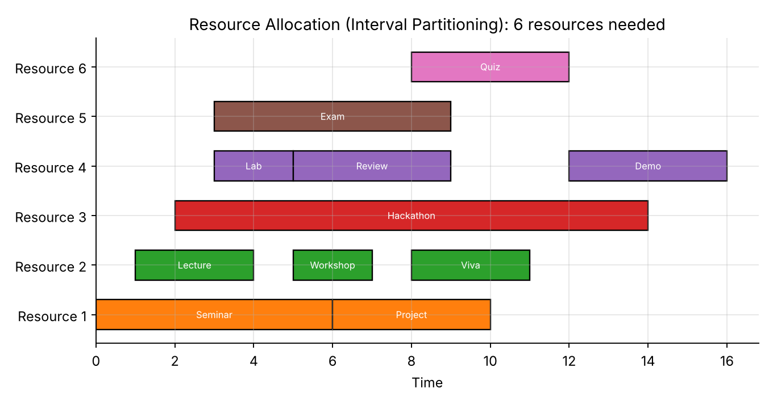
Figure 1: Resource allocation chart
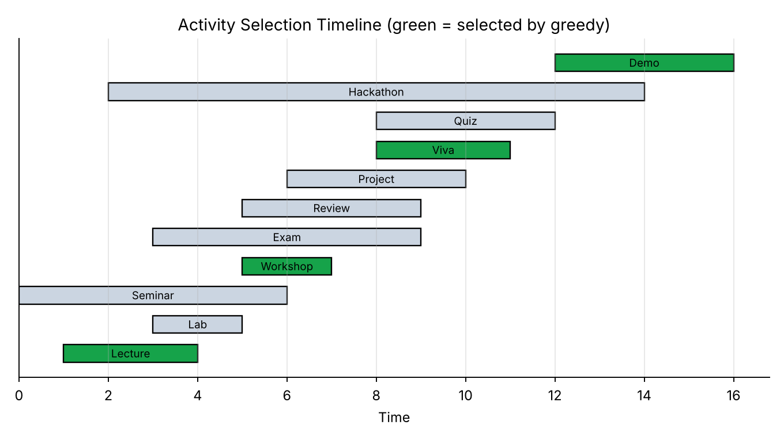
Figure 2: Activity selection timeline
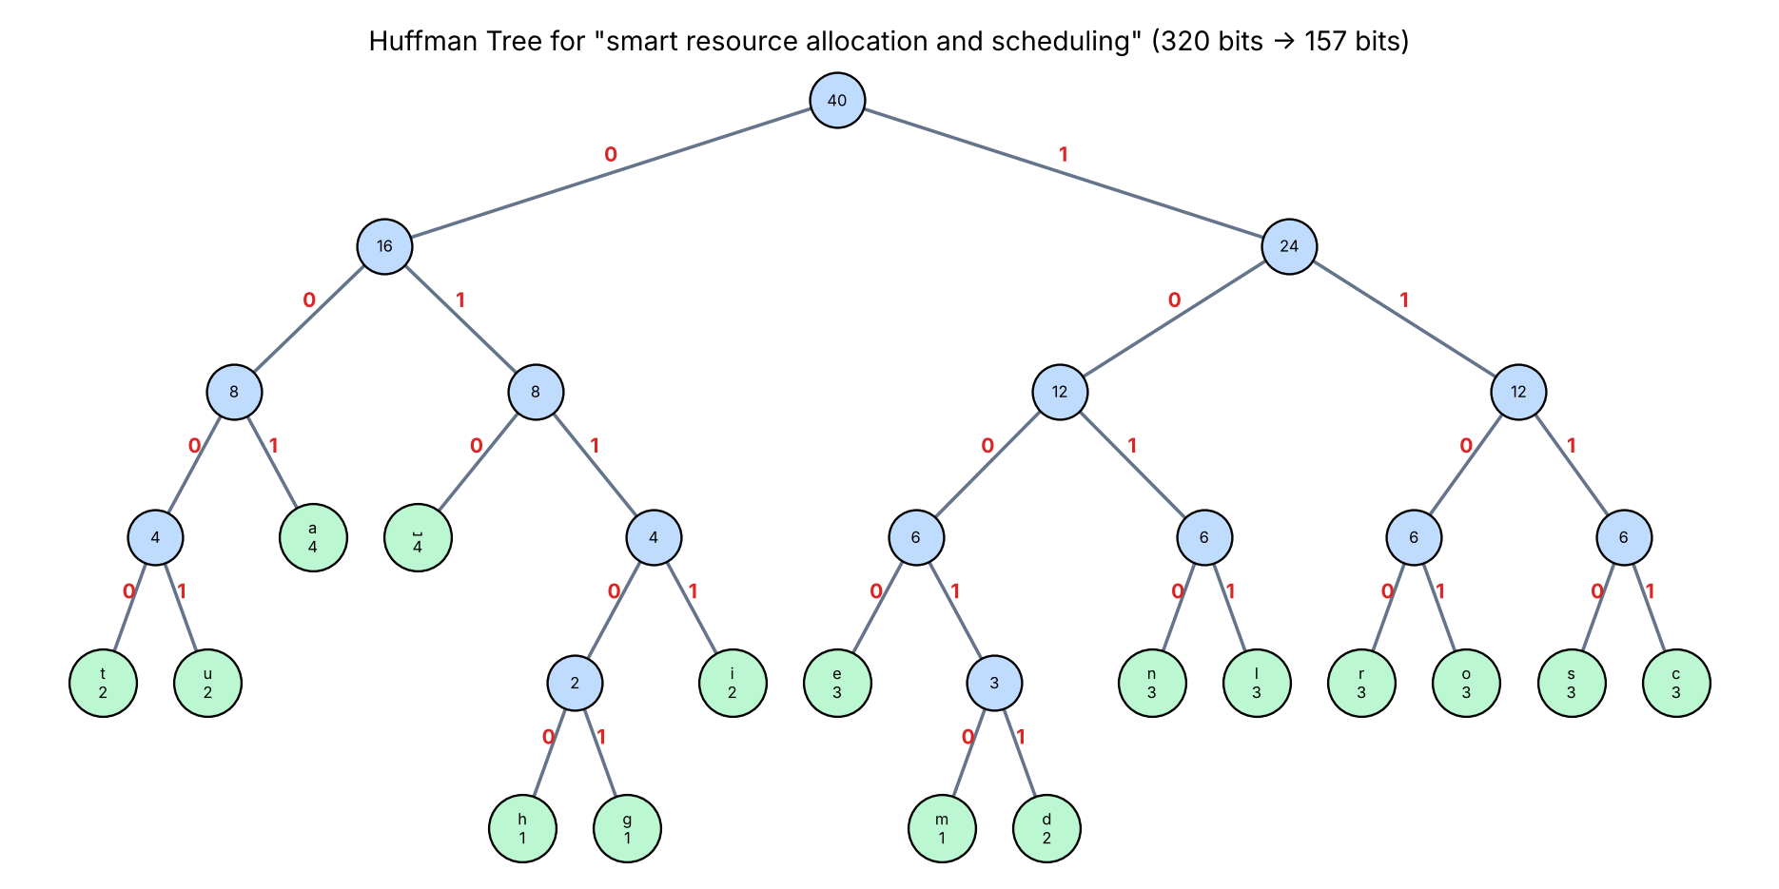
Figure 3: Huffman tree
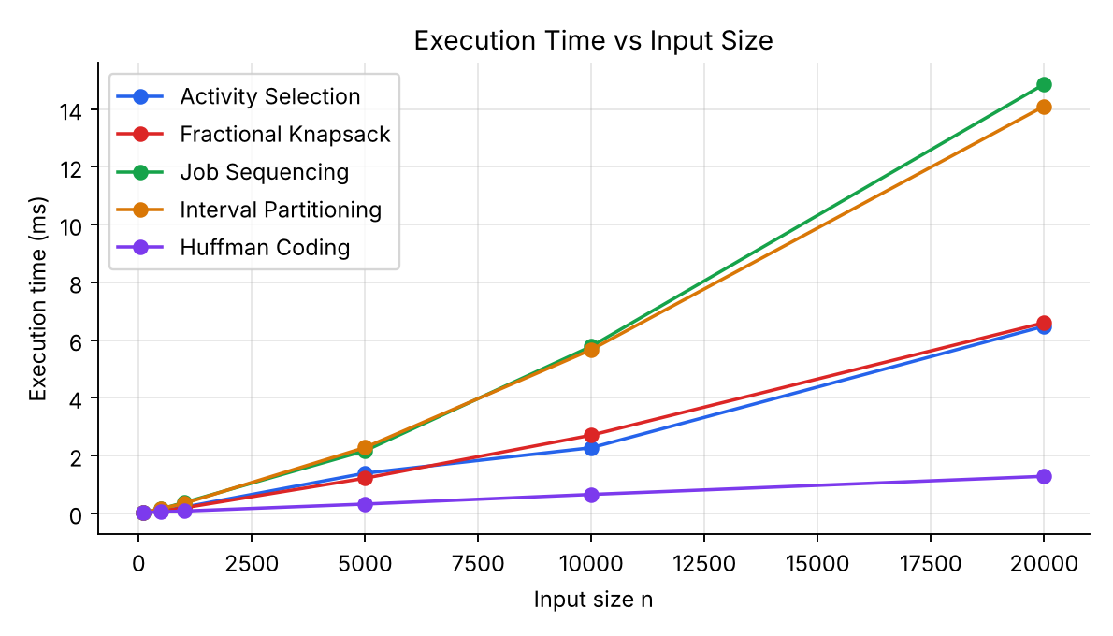
Figure 4: Execution time vs n
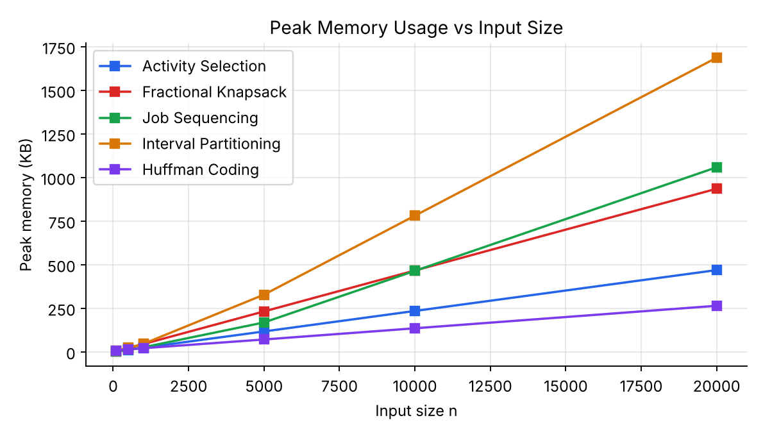
Figure 5: Memory usage vs n

7. Conclusion
All five greedy algorithms run in O(n log n) time (dominated by sorting or heap operations) and O(n) space. Greedy choices were correct for every problem here: Activity Selection, Fractional Knapsack, Interval Partitioning and Huffman Coding are provably optimal, and Job Sequencing with deadlines yields the maximum profit for unit-time jobs. Measured results confirmed near-linear growth for the tested sizes.

8. GitHub Link
[Paste your GitHub repository link here]

